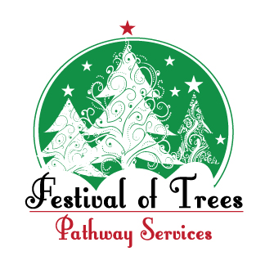
2025 Festival of Trees
Designer Entry Form
(Complete a form for each entry)
Entry Form due by Tuesday, October 28, 2025

Designer Tree: 6.5’ 4’ Wreath Centerpiece

Entry Title:


Contact Name: Phone Number:
Address:

Designer Name: Phone Number:
Address:

Designer Name: Phone Number:
Address:
Please provide how your Designer Name is to appear on signage and in printed materials

Designer Name(s):
Business/Organization:
Mail completed Entry to: Pathway Services, Festival of Trees Entry, 1905 W. Morton, Jacksonville, IL 62650
Email completed Entry to: Jessica Brogdon at jbrogdon@pathwayservices.org
Any questions contact: Jessica Brogdon – (217) 479-2320
Event Usage Only Entry # ____________
Not For Auction Sold To: _________________________

Deliver To: Auction # _______________
Amount $_______________
__Cash
Phone Number: ________________________ __Check #____________
__Debit / Credit _____________
Student Tree Sponsor: ____________________________________ Ref#____________________

