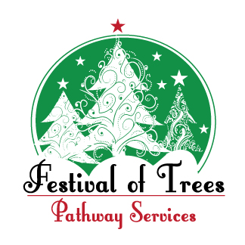 | 2026 Festival of Trees  Designer Entry Form  Please complete one form for each entry.

Entry Form due by Monday, October 26, 2026

ENTRY INFORMATION
Entry Type: ☐ 6.5' Tree ☐ 4' Tree ☐ Wreath ☐ Centerpiece
Name of Entry: _________________________________________________________________
Example: Winter Wonderland
CONTACT INFORMATION
Primary Contact: __________________________________ | Phone: _______________________
Address: __________________________________________________________________________
DESIGNER INFORMATION – List all designer/decorator names.
Designer Name(s): ___________________________________________________________________

___________________________________________________________________________________

__________________________________________________________________________________
Are you decorating for a business or organization? If yes, please list the name. If no, leave blank.

Business/Organization (if applicable): ________________________________________________________
How should we list the designer(s) on the event signage? Example: Jane Smith & Mary Jones and/or ABC Company
____________________________________________________________________________________

RETURN COMPLETED FORM TO:
Pathway Services – Festival of Trees | 1905 W. Morton, Jacksonville, IL 62650
Questions? Contact Jessica Brogdon at (217) 479-2320.
All entry forms are due by October 26, 2026

EVENT USE ONLY
Entry #: __________________ | ☐ Not for Auction
Purchased By: __________________________ | Phone: __________________________
Auction #: __________________ | Amount: $__________________
Payment: ☐ Cash ☐ Check #________ | ☐ Credit/Debit
Delivery Needed: ☐ Yes ☐ No | Ref #: __________________

